535/3

PHYSICS

PRACTICAL

Paper 3

Jul/Aug 2016

2¼ hours



**MUKONO EXAMINATIONS COUNCIL**

Uganda Certificate of Education

PHYSICS PRACTICAL

Paper 3

2 hours 15 minutes

INSTRUCTIONS TO CANDIDATES:

* Answer Question 1 and one other question.
* Candidates are not allowed to use the apparatus or write for the first fifteen minutes.
* Graph papers are provided.
* Mathematical tables and non – programmable silent electronic calculators may be used.
* Write on one side of the paper only.
* Candidates are expected to record on their scripts all their observations as these observations are made and to plan the presentation of the records so that it is not necessary to make a fair copy of them. The working of the answers is to be handed in.
* Details on the question paper should not be repeated in the answer, nor is the theory of the experiment required unless specifically asked for.
* Candidates should, however, record any special precautions that they have taken and any particular features of their method of going about the experiment.
* Marks are given mainly for a clear record of the observations actually made, for their suitability and accuracy, and for the use made of them.

1. In this experiment you will determine the length, **L0** of a pendulum

***(20 marks)***

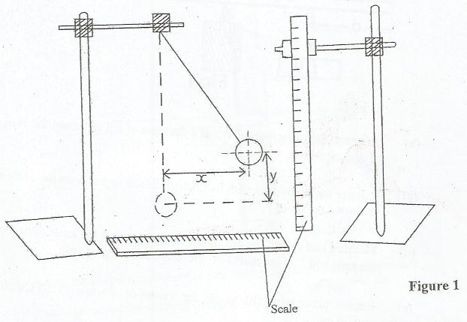

(a) Suspend a given pendulum bob from a retort stand.

(b) Displace the pendulum bob through a distance x=0.150m as shown in figure 1.

(c) Measure and record the vertical displacement y of the bob in meters.

(d) Repeat procedures (b) to (c) for x=0.200, 0.250, 0.300, 0.350, and 0.400m.

(e) Record your results in a suitable table including values of x2.

(f) Plot a graph of x2(**along the vertical axis**) against y(**along the horizontal axis**).

(g) Find the slope, S, of the graph.

(h)Calculate the length, **L0,** of the pendulum from the expression, **L0 =** 0.5S

2. In this experiment you will determine the focal length of a mirror ***(20Marks)***

(a) Fix the mirror provided in a holder.

(b) Focus a distant object onto the white screen.

(c) Measure and record the distance f0 between the mirror and the screen.

(d) Arrange the torch bulb, the dry cells, the switch and the white screen as shown in

figure 2.

**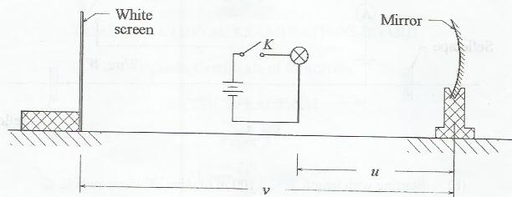 *Figure 2***

(e) Adjust the distance, u, of the torch bulb from the mirror to 15.0cm.

(f) Close switch, K.

(g) Adjust the position of the white screen to obtain a sharp image of the filament of the

bulb on it.

(h) Open switch K.

(i) Measure and record the distance v of the white screen from the mirror.

(k)Repeat procedure (e) to (i) for values of u=20.0, 25.0, 30.0, 35.0, and 40.0cm

(l)Record your results in a suitable table including values of x =

(m) Plot a graph of x (**along the vertical axis**) against v(**along the horizontal axis**).

(n) Find the slope,S,of the graph.

(o) Calculate the focal length, f from the expression f0 = 

**3.**  In this experiment, you will determine the resistance per meter length of the wire provided. ***(20 marks)***

***Figure* 3**

A

V

Bare wire, **W**

Cellotape

K

Crocodile clip

Rheostat

*x*

1. Connect the circuit shown in figure 3.
2. Adjust the length of the bare wire, W between the crocodile clips such that *x* = 0.300m; close switch **K**.
3. Adjust the rheostat until the current registered by the ammeter, **I** = 0.08A
4. Read and record the voltage reading, **V**.
5. Open switch, **K**.
6. Repeat procedures (b) to (e) for values of *x* = 0.400, 0.500,0.600, 0.700 and 0.800m
7. Disconnect the circuit.
8. Record your results in a suitable table including values of and
9. Plot a graph of  (**along the vertical axis**) against  (**along the horizontal axis***)*
10. Determine the slope, ***r*** of the graph.

**END**